***Pocket Closet App***

***Spring 2020***

***Fairfield University***

***Created By***

***Logan Pensa***

***Hemant Maheshwari***

***Adrian Gallant***

***Aaron Banson***

***Daniel Wilson***

**Table of Contents**

**Introduction**………………………………………………………………………………3

**Installation Process, Application Setup/Launch and Compatibility of Devices**……..….4

**Summary of Separate Functions of Pocket Closet**………………………………………5

**Login Page**………………………………………….…………………………………….6

**Sign Up Page**……………………………..………………………………………………8

**Security Question Page**………………………………………………………………….10

**Direct Feed/Home Page**..……………………….………………………………………..12

**Search Page**………………………………………………………………..……………..14

**Create Outfit Page**……………………………………………………...………………...16

**Profile Page**…………………………………………………………………………..…..18

**Followers and Followings Page**……………………………………………...…………...20

**Settings Page**……………………………………………………………………………...23

***Introduction***

Pocket Closet is a mobile application that assists both users and stores for the sole purpose of fashion. Bearing in mind, the main functionality is to allow users to create outfits in their virtual wardrobe and be able to receive deals or offers to buy from different clothing stores. The clothing stores will be able to market their products to their customers.

Pocket Closet was designed in a manner to be easy to use by regular users and the stores themselves. Regular users will be able to create outfits and see the outfits that others create through a posting feature so different users can interact with each other. Stores will be able to advertise their clothing products to the users of the app.

This app will open up a login page where first-time users will enter their credentials by choosing the appropriate option. After signing in, a login page will be present for returning users of the app. There are other components of the app that the user will interact with, such as creating new outfits, searching for other users and stores, viewing their feed, checking information based on followers and those the user is following.

***Installation Process, Application Setup/Launch and Compatibility of Devices***

This application was built using C# and MySQL. C# was used for the creation of the mobile portion of the application and the Web API. While MySQL was used for the creation of the database. This program was created using Xamarin and MySQL workbench and all parts of the program were created on both the Windows Operating System and a Mac Operating System.

The installation process is relatively simple, where the product can be downloaded via the Google Play store or the App store. So there is compatibility with both Android and Apple devices. When the installation/downloading process is completed, press on the appropriate icon or open it directly from the Google Play or App store.

***Summary of Separate Functions of Pocket Closet***

When you first open the Pocket Closet application there will be a login page that appears.

This is where you can enter a username and password if the person is a returning user. If the returning user logs their username and password, then they should click the login button when they are finished. They will proceed directly to their feed page and will be able to access the other functions of Pocket Closet. If the person is logging in for the first time, then that person should click the sign up button which will bring the user to a sign up page. There is a security question page where the user can reset their password if they forget the password they used to login before.

***Login Page:***

Username- The username is the name that appears on your profile once you login into the app. This is the name that other users will see at first before clicking on your profile icon and seeing any additional credentials (except any sensitive pieces of data like D.O.B). This name does not necessarily have to be your first name and last name.

Password- The password is a key of sorts that protects the user’s account from other users that should not be using another person’s account, other than their own. This will be a set key until the user decides to reset the account’s password into a new one.

Sign Up button- This button should be clicked/tapped for first-time users only. When the user clicks this button, the user will be sent to the sign up page.

Log In button- This button should be clicked/tapped for returning users only. When the user enters the necessary credentials, they should click/tap this button and the user will be brought to the direct feed page and have access to the other functions of Pocket Closet.

Forgot Password Button- This button brings the user to the forgot password page where they will be able to answer a security question and update their password.

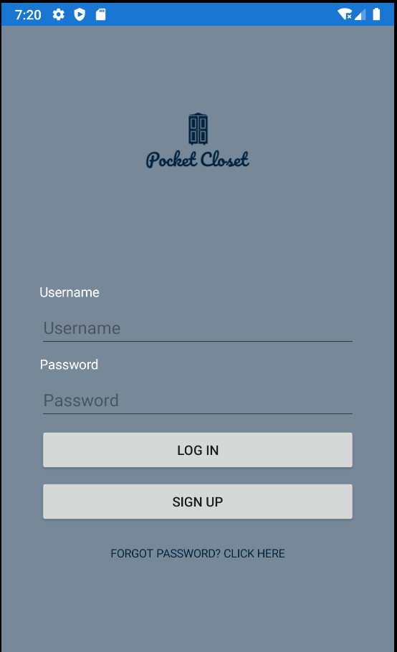

***Sign Up Page:***

Select a user type: The user is either a regular user or a store.

First Name: Enter your first name.

Last Name: Enter your last name.

Email: Enter a valid email.

Username: Enter a name for use in Pocket Closet. This name is the first name that other users will see when viewing your profile.

Password: This is a unique key that will keep other users from gaining access to the original user’s account.

Confirm Password: Enter your password again for security purposes.

Phone Number: Enter a phone number that you use. Can be used to retrieve your account or helps stores to direct ads about new products.

Sign Up button: Click this button to complete the sign up process. Once the user has signed up, the user should be able to log in through the login page.

Already Have an Account? Sign In button/link: This page will take the user back to the Sign Up page.

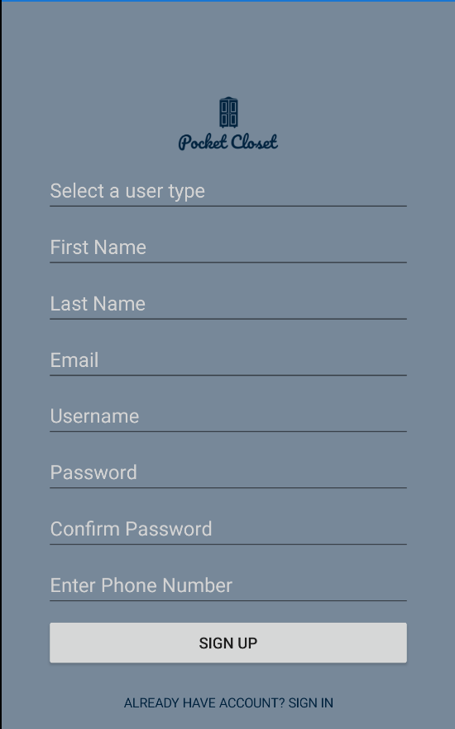

***Security Question Page:***

Enter the username: Enter the username that you/the original user is using from the last change made.

Email: The user should enter the email they entered for their credentials, as this can be used to email a confirmation that it was the original user and not another user trying to gain access for malicious purposes.

Enter answer: Enter the answer exactly as set from the sign up page.

Submit Request button: Click this button to move to the next page regarding access to your account.

Back To Login Page: Sends the user back to the login page.

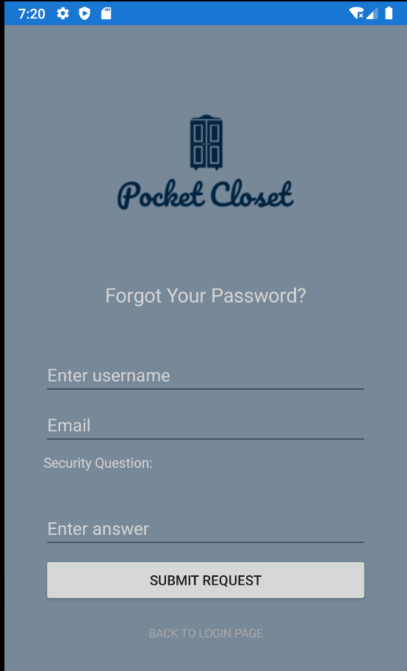

***Direct Feed/Home Page:***

This is the Direct Feed/Home page. The user will be able to view outfits posted by other regular users and stores. Other stores will be able to market their products directly to their customers such as shirts, pants, jackets, socks, shoes and other accessories. Other users upload their outfits and the user will be able to view them while choosing to follow them so the user would be able to track their fashion styles and how they change over time. Their profile picture will be displayed along with their username and the outfits that they posted.

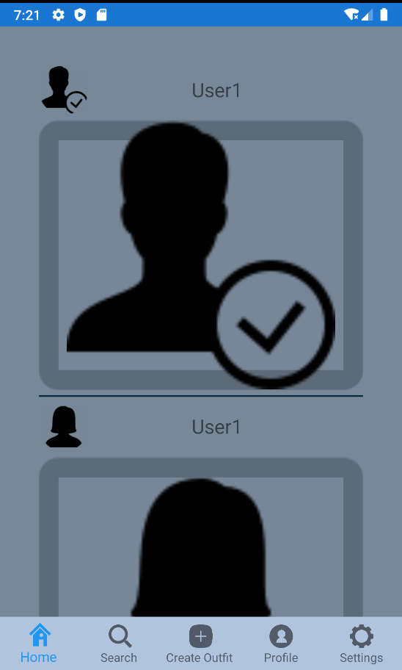

***Search Page:***

The search page serves as a way for the user to find other users and stores by their unique usernames. The user will type in a particular username, and there will be a list to choose from in order to find other users in order to view their outfits regardless of the type of user (regular or a store).

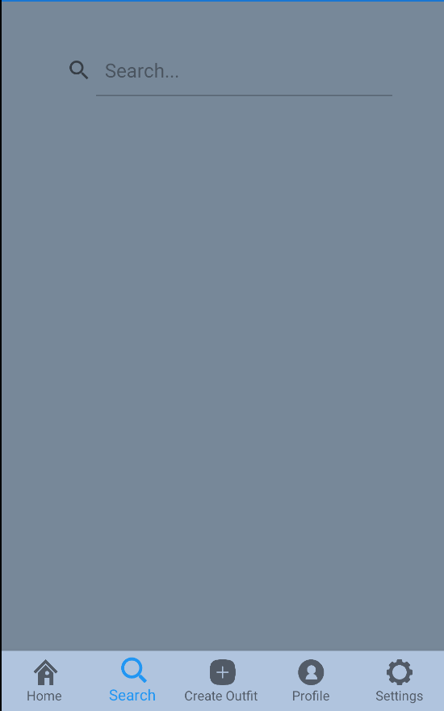

***Create Outfit Page:***

The Create Outfit page serves as a hub for the user to mix and match articles of clothing that are in their wardrobe and stores their outfits based on their user id. The user will be able to select either shirts or pants and compare them to see how they will look together. If the user is satisfied with the outfit, then the user should save the outfit into their profile. When other users visit the user’s page, they can view these outfits as well.

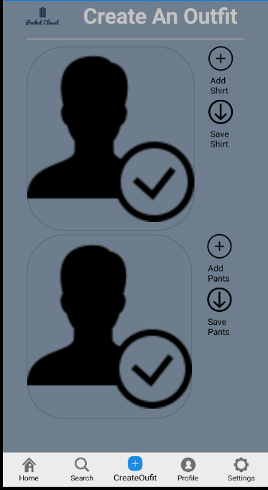

***Profile Page:***

Username: The user’s username appears in this field.

Posts: An ongoing count of how many posts the user has uploaded.

Followers: An ongoing count of how many other users are following the user in question.

Following: An ongoing count of how many other users, the user in question is following.

Full Name: The user’s full name is assembled based on the information given from the sign up page.

Edit Profile button: This allows the user to edit their personal information from the sign up page and edit their profile picture.

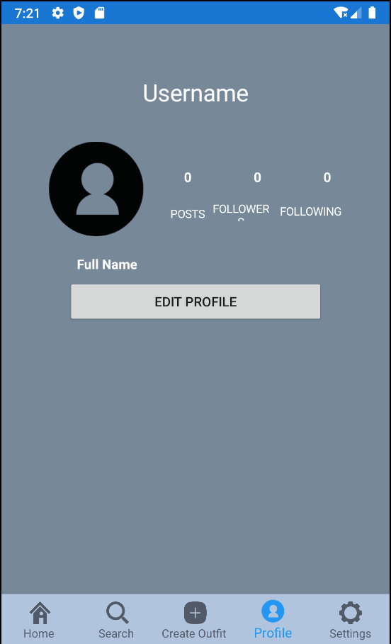

***Followers and Following Pages:***

The followers page will allow the user to view more information about the people that are following the user. Such information would include any posts and the outfits that they upload.

The following page will allow the user to view more information about the people that the user is following. Such information would include any posts and the outfits that they upload.

Both the followers and the followings page have a Back to Home Page button. When clicked, this will send the user back to the Home/Direct Feed page.

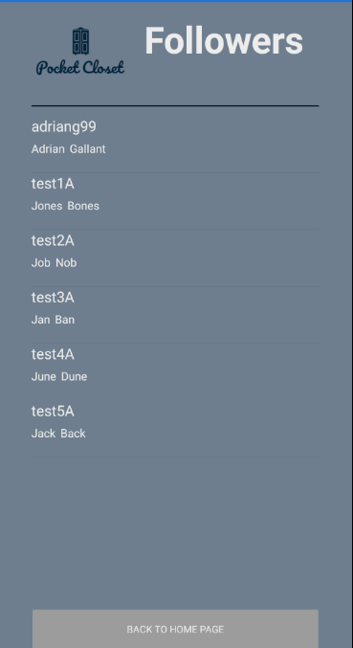

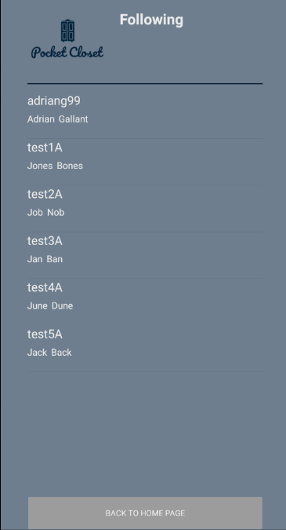

***Settings Page:***

First Name: The user can change their first name from their initial entry to something new.

Last Name: The user can change their last name from their initial entry to something new.

Email: The user can change their email from their initial entry to something new.

Phone: The user can change their phone number from their initial entry to something new.

Password: The user can change their password from their initial entry to something new.

Update Information button: When this button is clicked/tapped, all the new information entered will overwrite the information from the previous entry.

Log Out button: When this button is clicked/tapped, the user will sign out. This means that the user will have to sign in again when they open the app to use their account again.

